Shoova &Co. Website Documentation
1.Website Specifications
a. Website Objectives and Business Goals
TYRO is a service company that provide an online platform that promotes TYRO’s professional sneaker cleaning services. The website enables customers to learn about the services offered, make enquiries and contact the business easily. It also strengthens TYRO’s online presence and supports business growth.
Business Goals:
-Increase awareness of TYRO’s sneaker cleaning services.
-Promote the company’s brand and service quality.
-Provide customers with easy access to service information and contact details.
-Encourage online enquiries and bookings.
b. target Audience
Demographics:
-Target audience include sneaker owners, colleagues & students, university, young professionals, athletes and fashion enthusiasts aged between 16 and 40 years.
-Most users have basic to intermediate digital skills and regularly use smartphones and computers to search for services for services online.
-People looking for reliable, affordable and professional sneaker cleaning services.
Type of Website
TYRO is a business service website that promotes professional sneaker cleaning services. The website provides information about cleaning packages, pricing, the cleaning process, customer testimonials and contact details. It also includes feedback or booking form to allow customers to communicate directly with business.

2.Information Design & Taxonomy
Site Hierarchy& Navigation
Top level Navigation: Home, About Us, Services, Gallery, Contact Us, Feedback
The website uses a consistent navigation menu displayed on every page. Users can move from the Home page to any other page using the navigation bar.
Every page also contains a link back to the Home page, ensuring there are no broken navigation paths.
Storyboard Flowchart:
Home
About Us
Services
Gallery
Contact Us
Feedback

SITE MAP
HOME

Feedback
Customer
Enquiries
Feedback
Submit
message
Contact Us
Business
Details
Location
Phone

Gallery
Before &After photos Testimonials
ServicesCleaning
Packages
Pricing
Booking

Cl
About Us
Company
History
Mission
Vision

3.Page Template Design
The TYRO website follows a clean, modern, and responsive design that reflects the company’s professional sneaker cleaning services.
-Each page includes a header with (the TYRO logo and navigation menu.)
-A main content section and a footer containing (contact information, social media links and copyright details.)
-The design uses high-quality images, clear typography, sufficient white space and a call-to-action buttons to improve usability.
Home Page Website
WIREFRAMES
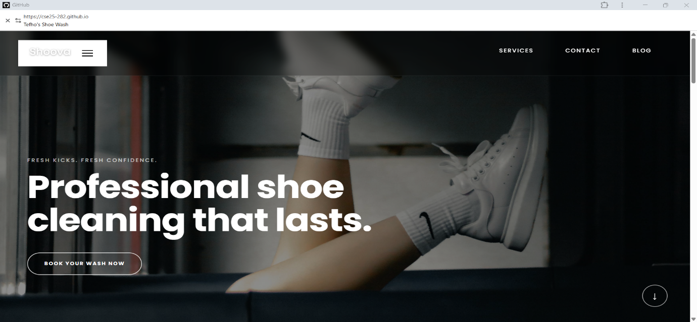
Service Page Wireframe
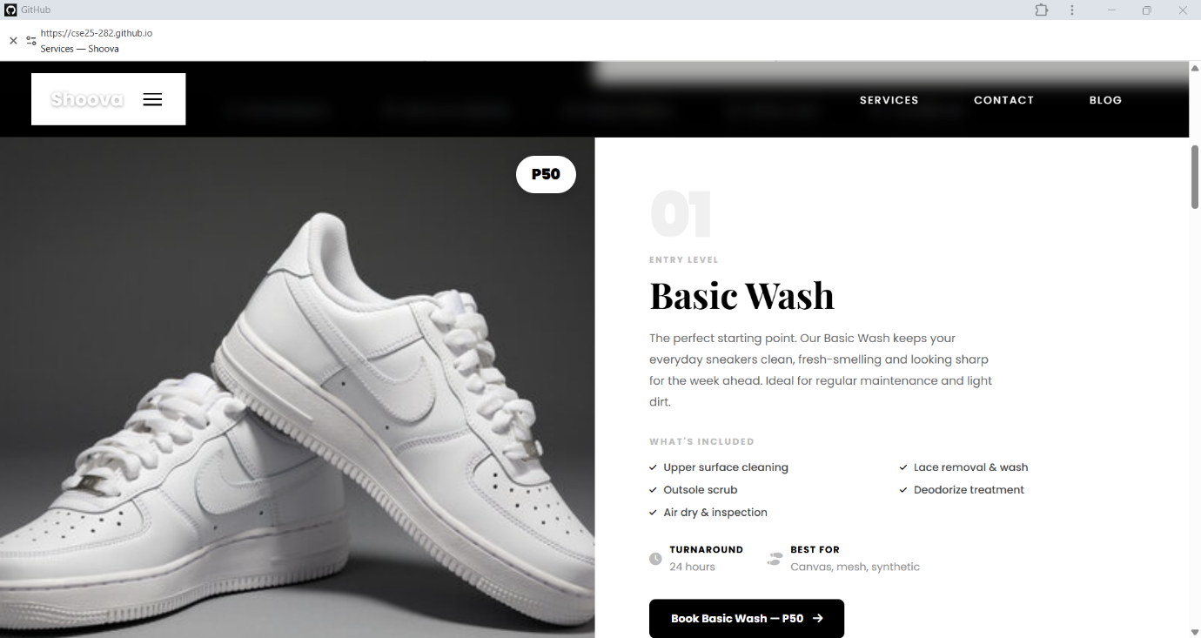
Contact Page/Feedback Page
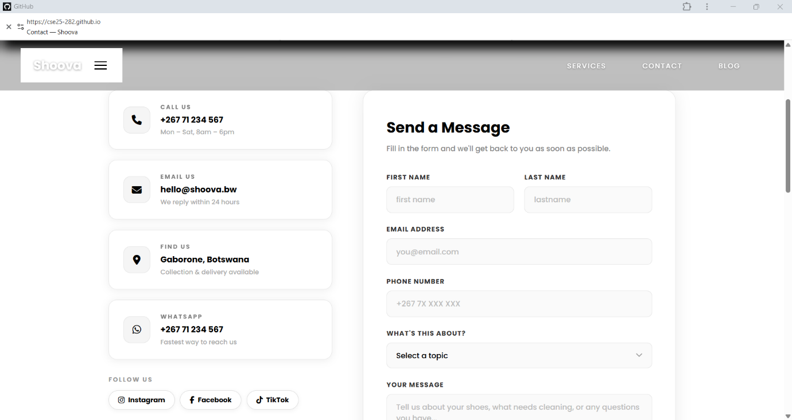

Design Features
-High quality sneaker images.
-Clear sections with proper spacing
-Consistent layout and navigation on every page.
-Clear call to call-to-action buttons such as Book Now and Contact Us.
4.Technical Belief
-The TYRO website will be developed using HTML5 for the website structure, CSS3 for styling and java Script for interactivity.
Tools:
-Bootstrap 5 will be developed using Visual Studio Code (VS Code) with Git and GitHub used for version control and hosting on GitHub Pages. Canva and GIMP and will be used to create and edit images and graphics.
5.Quality Assurance
Testing Approach:
Browser Compatibility: Chrome 128+, Firefox 130+, Edge, Safari 18.
Devices: Desktop (1920px+), Tablet(768px+), Mobile(375px+).
Function: To confirm that the layout is responsive and all navigation links, buttons,and the feedback form function correctly.

6.Publishing &Promotion
Hosting: Deployed as static site on GitHub Pages
Process:
-git int
-git add
-git commit -m “Initial Website upload”
-git branch -M main
-git remote add origin<repository-link>
-git push -u origin main
GitHub Repository:
https://github.com/yourusername/yourrepository
Website URL:
https://yourusername.github.io/yourrepository/
7.Future Developments/Recommendation
To enhance the TYRO Website, future improvements may include:
-An online booking system.
-Secure online payment integration.
-Live chat support for customer enquiries.
-Customer accounts to track bookings and service history.

